|  |
| --- |
| 新东方在线英语学习 |
| 新概念 1 册 |
| Lesson31-32 |



扫一扫。更多有趣的英语资讯。

# Lesson 31 单词讲解

1. garden: 花园

in the garden 在花园里\ a gardener 园艺师

1. 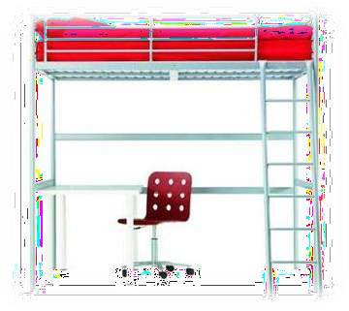under: prep. 在…的之下

床下面有一把椅子。

There is a chair under the bed.

1. tree: 树

树下 under the tree

家谱 a family tree

1. climb: v. 爬，攀登

climb the mountain 爬山

1. who: 谁
2. run: v. 跑

run after 追赶

a runner 跑步运动员

Liu xiang is a runner.

1. grass: 草地ge rua si
2. after: prep. 在…之后

After you！ 您先请。

1. across: prep. 穿 过 啊 keaosi

go across the street walk across the street run across the street

1. cat: 猫

There are two people in the room. They are talking.

There is a boy in the tree. He is climbing the tree.

There is a girl under the tree. She is reading.

1. She is sitting under the tree. sit-sitting
2. He is climbing the tree. climb-climbing

# Lesson 31 课文讲解

1. I beg your pardon?

Pardon? Excuse me? Sorry? Say it again.

1. What about …?

I am a teacher. What about you?

I am learning English. What about you? I like rice. What about you?

…

1. 他正穿过那片草地。

He is acrossing the grass.

He is going\ walking\ running across the grass.

1. It’s running after a cat. run after 追赶

# Lesson 31 语法讲解

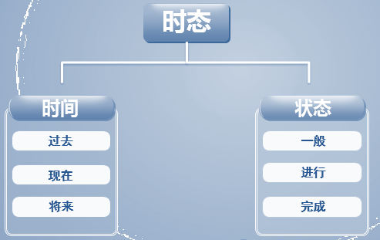

现在进行时态时间：现在 状态：进行

此时此刻正在做的动作。

总结一下：

1. 一般+ing；
2. 以不发音的e 结尾, 去e +ing;
3. 辅+元+辅（汉堡堡结构），双写辅音字母+ing,除 opening.

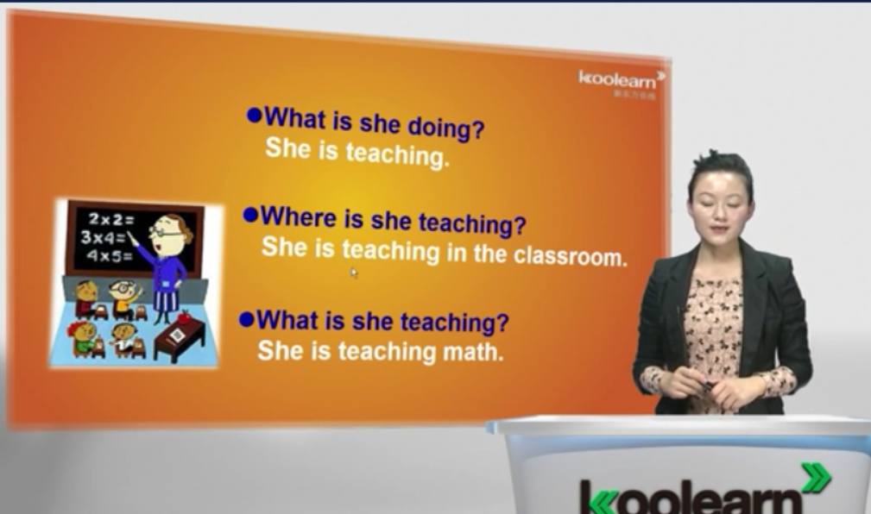

# Lesson 32 单词句型讲解

1. type: v. 打字

typing

1. letter: 信lai de er

a love letter 情书

1. basket: 篮子

basketball 篮球

1. eat: v. 吃

eating

1. bone: 骨头 bou n
2. clean: v. 清洗clean 干净的clean the room cleaning
3. tooth: 牙齿复数 teeth foot- feet toothbrush
4. cook: v. 做饭

cooking

My mother is cooking.

1. milk: 牛奶
2. meal: 饭，一顿饭

cook a meal

1. drink: v. 喝

drinking

She is drinking some water.

1. tap: 水龙头

打开水龙头 open the tap turn on the tap

turn off the tap

1. What’s she\he\it doing?
   1. 他正穿过那片草地. He is acrossing the grass.

He is walking across the grass. running

going

他们正跨过那座桥.

They are overing the bridge

They are walking over the bridge. running

going

# 结论： 时态是动词的变化。

**Lesson 31&32 知识拓展**



clean and clear

